**LAPORAN**

**INSTALASI & MENJALANKAN MongoDB**

Disusun untuk memenuhi tugas mata kuliah Topik Khusus

Dosen Pengampu: Mutia Rahmi Dewi, S.Kom., M.Kom



Oleh

**ERFAN FADHIL JUZAR**

**NIM. 2211082006**

**PROGRAM STUDI TEKNOLOGI REKAYASA PERANGKAT LUNAK**

**JURUSAN TEKNOLOGI INFORMASI**

**POLITEKNIK NEGERI PADANG**

**2025**

1. Installasi MongoDB

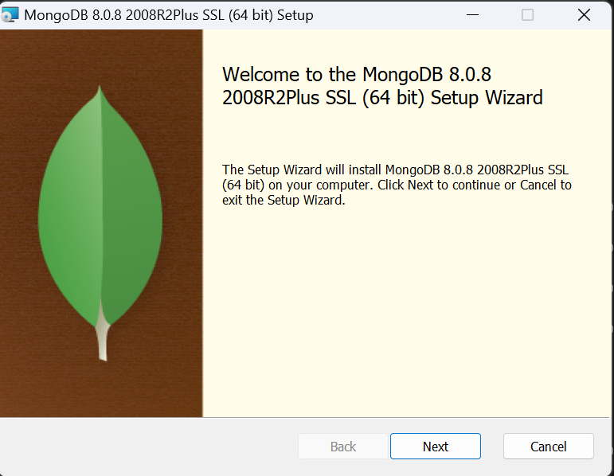

1. **CREATE TABLE di MySQL**

1. **Clone the Repository**

1. **Create a Product**

1. **Get All Products**

1. **Get a Specific Product**

1. **Update a Product**

1. **Search Product**

1. **Delete a Product**

1. **Menambahkan Data (Insert)**

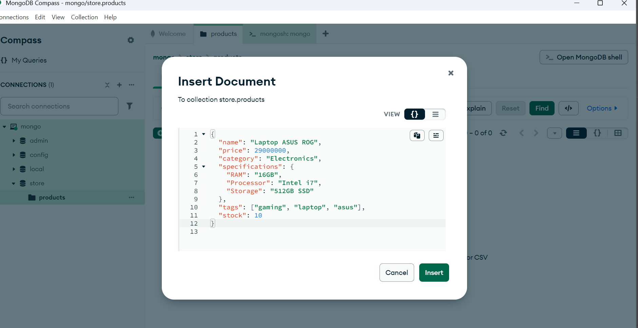

1. **Menampilkan Semua Data**

1. **Mencari Berdasarkan Nama**

1. **Mencari Berdasarkan Kategori**

1. **Mencari Berdasarkan Tag**

1. **Menampilkan Produk dengan Harga di Atas 25 Juta**

1. **Update Harga Produk**

1. **Menambah Stok Produk**

1. **Menghapus Produk**

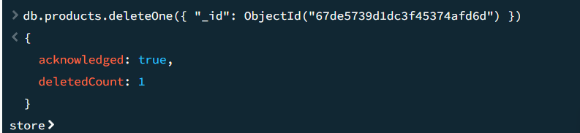

1. **Pencarian Produk dengan Banyak Filter**

1. **Pencarian dengan Kata Kunci (Full-Text Search)**

1. **Sorting (Urutkan Berdasarkan Harga Terendah)**

1. **Filter Produk yang Tersedia (Stock > 0)**

1. **Pencarian Produk Berdasarkan Tags**

1. **Pencarian Produk dengan Pagination (Limit & Skip)**

1. **Produk dengan Harga Diskon**

